Chapter 17, Problem 18.

Determine the fundamental frequency and specify the type of symmetry present in the functions in Fig. 17.56.

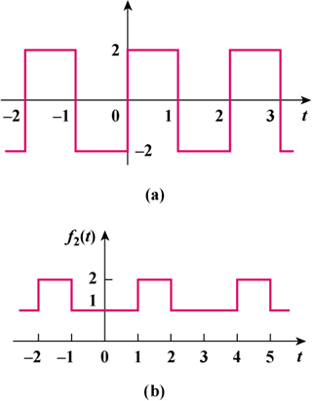

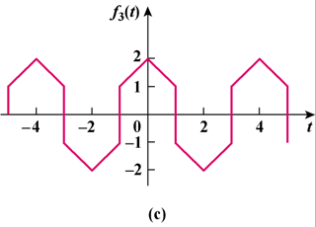
Figure 17.56
For Prob. 17.18.

